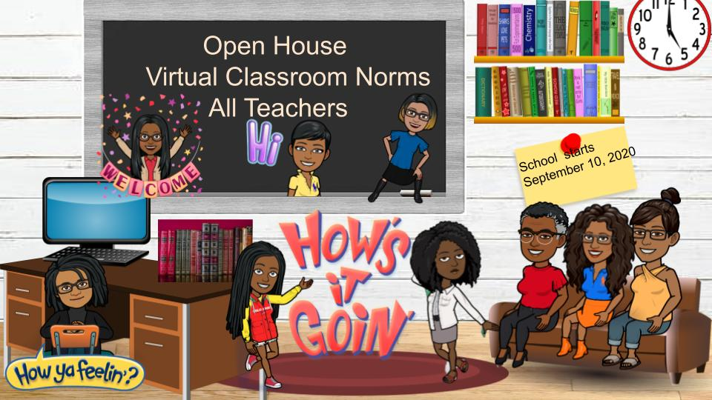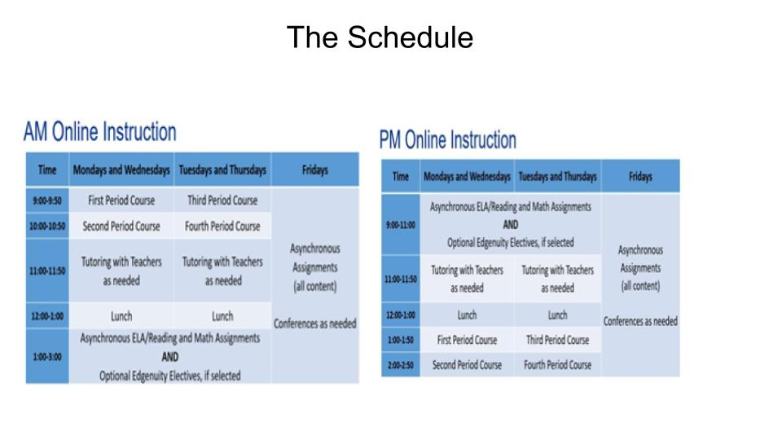

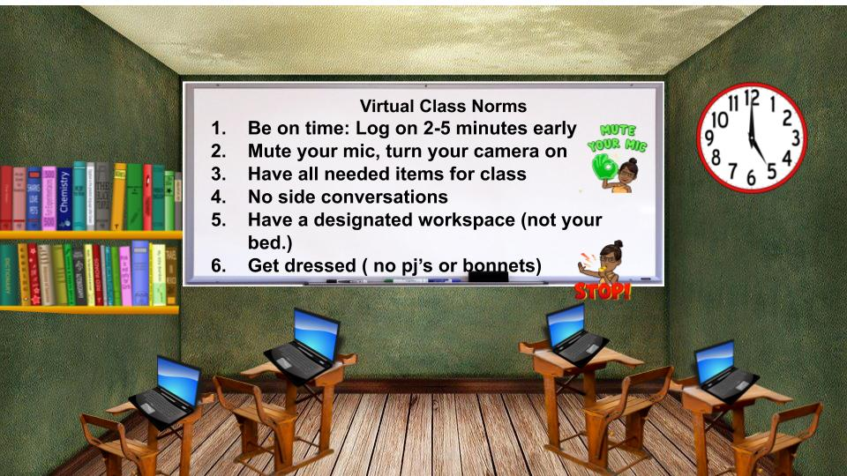

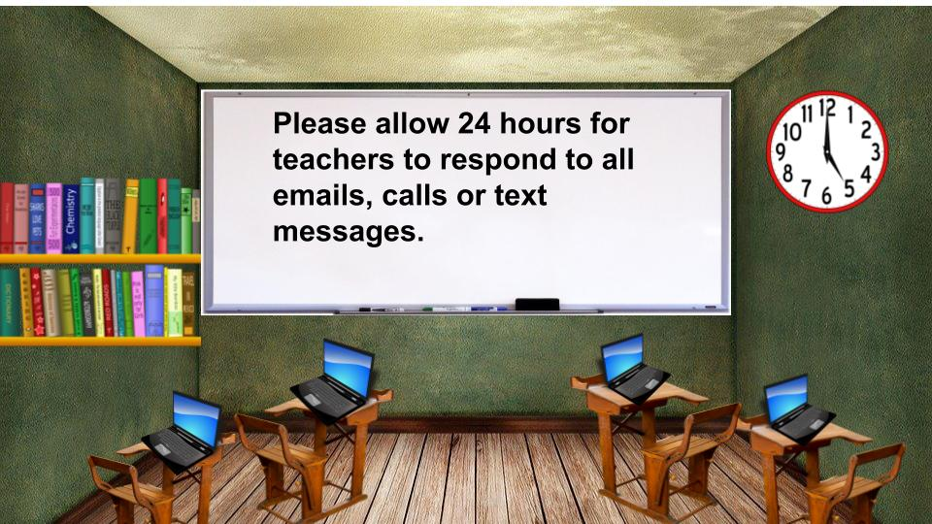

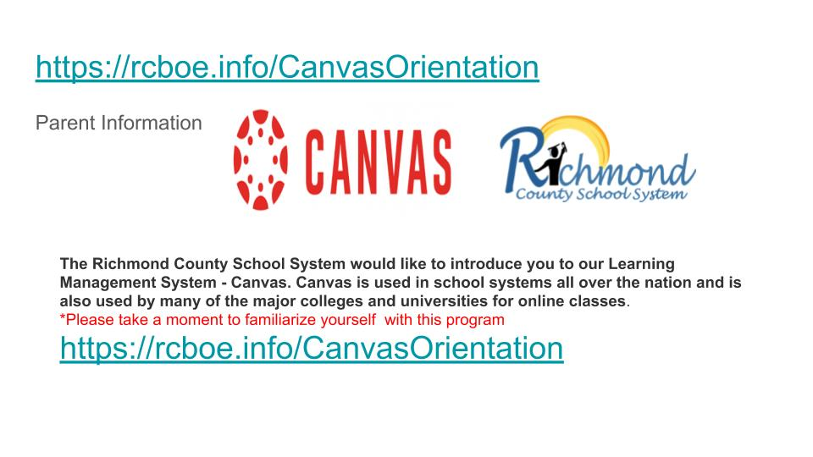

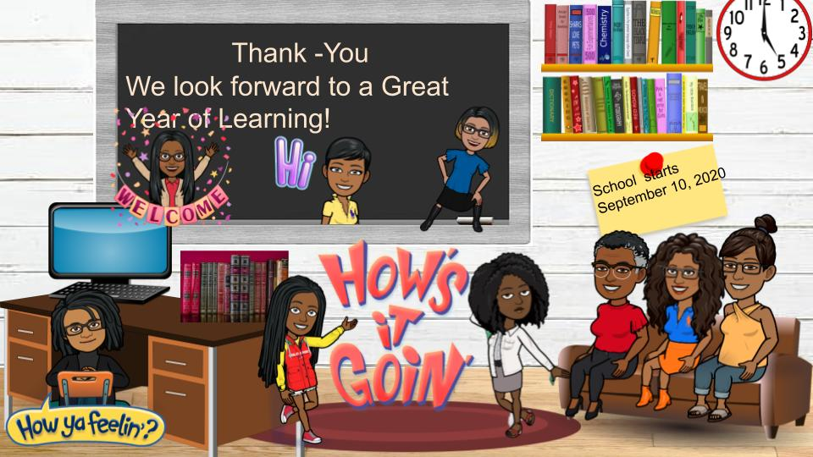

**Parent Canvas Directions**

Before September 10th, we recommend that students and parents complete the Canvas Orientations found at [rcboe.org/canvas](https://www.rcboe.org/canvas). We recommend that students send their teachers a practice message inside Canvas just to let the teacher know the student is ready for September 10th. The orientations will give students and parents a high-level introduction to the features Canvas offers.

Parents are able to connect to their students’ accounts by “pairing.”

1. Please download the Canvas Parent app from your phones. This will allow parents to receive notifications on their phones. It is free.

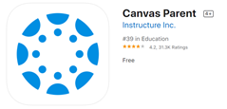

1. The student will log into his/her Canvas account through Launchpad. Once in Canvas, click on your account (circle with silhouette or photo) and click **QR for Mobile Login.** This will generate a QR code that is valid for 10 minutes. Parents can scan the QR code from their Canvas Parent app. This will take parents directly to the student’s page. 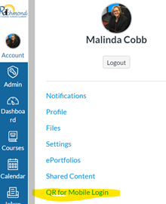
2. Next, parents will be asked for the student’s pairing code. From the student’s account, the student will select Settings (see image above). In the Settings, there will be a button on the right side of the page called **Pair with Observer**. When the user presses this button, it will generate a short pairing code. Parents will enter this code in the app. Parents only have to do this process once for the child’s educational career (K-12).

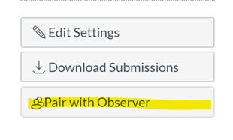

1. The parent and student are now paired. Repeat the same steps with pairing codes to add additional children if needed.
2. For directions using a Desktop or Laptop for pairing, please search for **RCBOE Parents** in the menu.